
LADY MEMBERS

SEPTEMBER 2015

CAPTAINS MESSAGE
It has been a good month for golf. Our numbers are up and the weather is great.

Just a bit of house cleaning to mention.

- The time to play 18 holes is 4 hours, including your halfway stop. How about putting yourself on the clock and time yourself? Let me know how you go.

- I am proposing that 1 day a month we mix things up by playing with someone you don’t normally play with. Just give it a go! Please let me know what you think of this suggestion.

- I am going through our Contact List and ringing all the girls I don’t know or haven’t seen for a long time. So far I have got 2 girls who are returning to Saturday golf – Judy Suckling and Sarah Wells. Welcome back ladies. If you know anyone interested in playing golf please bring them along. Remember your FREE games card from Brett. Use it or lose it.

Maureen Hughes, Ladies Captain
CHAIRPERSONS REPORT
Thanks everyone for keeping the numbers coming in regularly on Tuesday mornings for our Ladies competition.

I would especially like to welcome our new member Hikinga Eileen Wirihana who has played competition in NZ a little while ago and who is hoping to join us on Tuesdays. It is good to see another new face.

Also, I think everyone would have received some introductory 18 hole vouchers from Brett recently,
so please invite someone new to join you on the golf course. Remember, the more the merrier.

Once again, the ladies excelled themselves bringing along lunch on our recent Mixed 2 Person Ambrose day. Next month on 15th September we have a Mixed

4BBB Stableford with Fred Boyce as our sponsor. Looking forward to another great turn out.

Now that it is warming up and spring is almost sprung we will be starting earlier. 8.00 am as of 1st September. So don’t forget to arrive early. Happy golfing,

Janet Fay, Chairperson

SPECIAL NOTICES
- Committee Meeting: Don’t forget to get your suggestion/question/comment to Secretary Jacqui no later than Tuesday 29th September so it can be added to the Agenda for the next Committee Meeting on Tuesday 6th October.

- September Comp Details
1st – last Monthly Medal for 2015
8th – Captains v Presidents Single Stableford
15th – Mixed 4BBB Stableford
- Sponsored by Fred Boyce
22nd – 2 Person Ambrose
29th - Medal of Medals – Qualifiers are: Jo Etherden, Lois Smith, Cheryl Capwell, Marie Bansgrove, Shan Brown, Esme Katz, June Schipplock & Grace Borchert.

- October Event CHANGES:
6th - now Texan 4 Ball – Sponsor Shan Brown
13th – Single Stableford - Sponsored by
Lorraine Edwards & Lorraine Videroni

- Our next Theatre Night is –
Wednesday 7th October 8pm
Incinerator Theatre, Burley Griffin Drive, Ipswich.
Cost is $23 (+bring a plate for supper at interval)

Lorraine Edwards will hand out flyers very soon – so keep your eyes peeled.

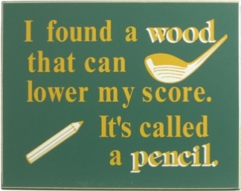
MAJOR RESULTS
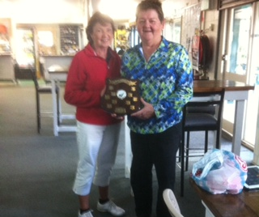
Lorraine Videroni & Shan Brown win the
Daphne & Alex Allan Trophy Day on 21st July
****************************************************************
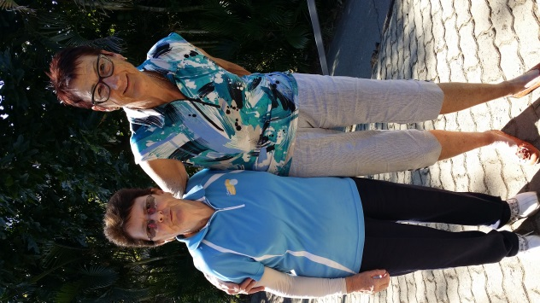

The final pairing for the 2015 Handicap Matchplay –
Maureen Hughes and Irene Wallis.
****************************************************************
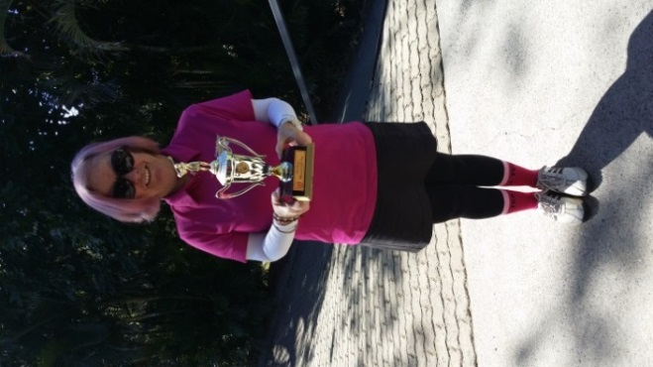
Di Murakami wins the Dot Preston Trophy
on 18th August 2015
****************************************************************

DID YOU KNOW………………
Out of Bounds
If your ball has gone out of bounds you must re-hit your next shot (with penalty) from the same position - not from point of entry to the out of bounds.
***************************************************************
Etiquette
If you have not already done so, please read the Etiquette Section – not more Rules as such, but a practical guide to getting around the course safely, in good time, with consideration for others and having taken good care of the course.
See Page 18 of the Rules of Golf handbook available free from our Golf Shop.
***************************************************************NCR (No Card Returned)
If you enter a competition and do NOT submit your scorecard, your entry is marked NCR. A player who has 5 NCRs (without an acceptable approved reason) in their last 20 scores on Golflink will have their handicap automatically suspended and listed as PROVISIONAL by Golflink until such time as there are fewer than 5 NCRs in their last 20 active scores.
This means:
1. You CANNOT win competitions, vouchers or balls in the rundown – but can win balls in NTP/Approach.
2. You are ineligible to qualify for honour board events.
3. If you play in 4 Ball or Ambrose events your partner/s will also be ineligible to win.
4. You are ineligible to play pennants or represent the Club until such time as their handicap status reverts to NORMAL.

To reinstate a handicap to NORMAL status you have to play single competitions (which are uploaded to Golflink) until there are fewer than 5 NCR scores in your last 20 active scores. Adhoc social scores will NOT be accepted to reinstate a handicap.

So please remember to return ALL your scorecards if you are entered in a competition. If for some reason you are unable to complete a round speak to your Captain or Handicapper and explain the issue. If you can’t find your Captain or Handicapper to discuss your round then write the reason on your card and return it – your Captain or Handicapper may contact you for clarification.
***************************************************************

